**ACME Project**

**Weekending: 06/19/12**

**Project Overview**

|  |  |  |  |  |  |
| --- | --- | --- | --- | --- | --- |
| **Project Number** | 05-133 | | **Client Contact Name** |  | |
| **Project Start** | 02/07/12 | | **Project Manager** |  | |
| **Project End** | 05/13/12 | | **Account Manager** |  | |
| **Schedule Status** | On Track |  | **Budget Status** | On Track |  |

**Project Description**

The IT Operations team at InfoSpace would like to implement an Enterprise Project Management (EPM) solution for better management of their project portfolios and their project resources, in order to improve strategic prioritization of their corporate initiatives. We will deploy a pilot for IT Operations that can serve as a model and first step for EPM across InfoSpace. The desired goals for this pilot are:

* Reporting and management across their portfolio of projects
* Tracking and reporting of Key Performance Indicators (KPI’s) for Work Budget and Schedule
* Development of initial solution for resource allocation, capacity planning, and work leveling
* Business Process development to support the successful deployment of these EPM goals
* Training for EPM pilot team

**Current Activity Update**

**Tasks Complete or in Progress this Status Period:**

* Executive training complete

**Upcoming activities:**

* July 23, Team Member Training

**Current Project Financials**

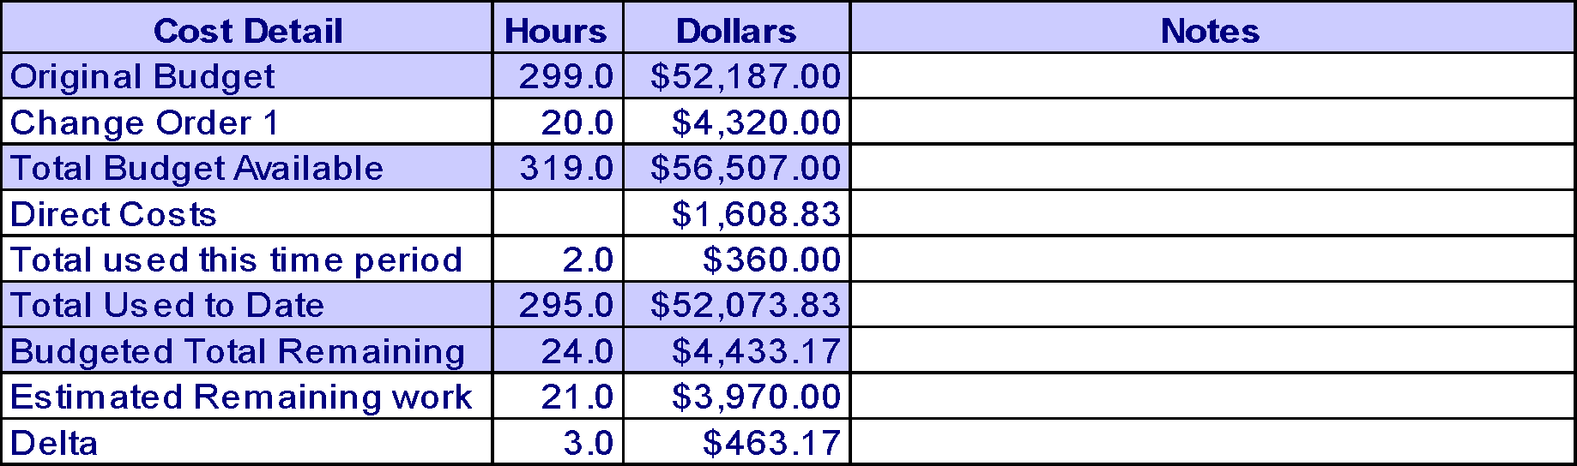

Note: Invoices to date:

|  |  |  |
| --- | --- | --- |
|  |  |  |
|  |  |  |
|  | **Total** |  |

**Current Risks, Action Items, Issues, Decisions, Changes, Business Process, and Training**

**Risks**

|  |  |  |  |  |  |
| --- | --- | --- | --- | --- | --- |
| **Opened-ID** | **Risk / Update** | **Trigger Event to Watch** | **Probability** | **Impact** | **Overall** |
|  |  |  |  |  |  |
|  |  |  |  |  |  |

**Action Items**

|  |  |  |  |
| --- | --- | --- | --- |
| **Opened-ID** | **Action Items / Updates** | **Owner** | **Target Date**  **Status** |
|  |  |  |  |
|  |  |  |  |

**Issues**

|  |  |  |  |
| --- | --- | --- | --- |
| **Opened-ID** | **Issues / Updates** | **Owner** | **Target Date**  **Status** |
|  |  |  |  |
|  |  |  |  |

**Decisions**

|  |  |  |
| --- | --- | --- |
| **Date-ID** | **Decision Log** | **Owner** |
|  |  |  |
|  |  |  |

**Change Log**

|  |  |  |  |
| --- | --- | --- | --- |
| **Date** | **#** | **Change Title** | **Status** |
|  |  |  |  |
|  |  |  |  |

**Business Process Changes**

|  |  |  |
| --- | --- | --- |
| **Date-ID** |  | **Owner** |
|  |  |  |
|  |  |  |

**Training Needs**

|  |  |  |
| --- | --- | --- |
| **Date-ID** |  | **Owner** |
|  |  |  |